The real structure of γ-Fe phase of rolled 1.4470 duplex steel after shot peening
M. Rušin, J. Čapek, K. Trojan, N. Ganev
Department of Solid State Engineering, Faculty of Nuclear Sciences and Physical Engineering, Czech Technical University in Prague

Abstract
Duplex stainless steels exhibit better properties, such as corrosion resistance, compared to single-phase steels. They are widely used in many engineering areas. Shot peening is commonly used technique in surface machining. It is used to further improve the final properties, such as service life. It is essential to know how this process affects the so-called real structure, which to great extend determines the final properties of the steel. The impact of shot peening intensity on crystallite size, residual stresses and preferred orientation was studied. It was found that shot peening caused a reduction in crystallite size in subsurface layers. It also led to an increase in compressive residual stresses in near-surface regions. The influence on preferred orientation was not as strong, yet some crystallites were rotated and reoriented.
Key words: X-ray diffraction; Duplex steel; Shot peening; Real structure.

Introduction
Duplex stainless steels (DSS) are a family of grades which provides significantly greater strength than the austenitic grades, while exhibiting good ductility and toughness. They also exceed austenitic grades in corrosion resistance, which is primarily a function of their alloying elements such as chromium, molybdenum, tungsten, and nitrogen. Due to their mechanical, corrosion properties, and reduced cost, DSS are widely used in areas such as automotive, aviation industry, civil engineering, and food storage. Metallurgy of DSS changes with chemical composition and manufacturing processes. Two main phases are ferrite (α-Fe) and austenite (γ-Fe), mostly in a 1:1 ratio. [1]
Shot Peening (SP) is used to further improve the final mechanical properties of the materials. This technique involves bombarding the machined piece with small spherical media. As a result, the material’s surface undergoes plastic deformation. This leads to generation of compressive residual stresses in the surface and subsurface regions of the peened material. Compressive stresses provide considerable increase in service life, since crack initiation, fatigue, and stress corrosion failures are reduced in a compressively stressed zone. Apart from residual stresses, SP also influences other parameters. Cold-working effect of SP causes increase in surface hardness due to work hardening, surface texturing or closing of porosity. [2]
The anisotropy of macroscopic properties of materials, such as DSS, is influenced by their real structure, which may change during the mechanical or thermal processing. Therefore, it is necessary to determine and describe the real structure and its depth profile after the rolling and SP. X-ray diffraction techniques were used to evaluate the impact of SP intensity on crystallite size, residual stresses, and preferred orientation (texture). The depth distributions of these parameters in γ-Fe phase are described.

Experiment
Three samples were produced from 1.4470 DSS plate of 3 mm thickness. At first, the plate was annealed at a temperature of 650 °C for 7 hours and cold rolled to half of the original thickness – 1,5 mm. Additional annealing was applied to reduce the residual stresses originating from the previous processing. Several samples were created by cutting the plate into smaller pieces. Three of them were chosen for this study. One, which was not shot peened for reference, was labelled N, and two peened with pressure 1.5 bar and 7 bar were denoted P1.5 and P7, respectively. Rolling (RD), transversal (TD), and normal (ND) directions created their coordination system. SP treatment was carried out using quenched steel shots with diameter 0,43 mm. Using air pressure 1,5 and 7 bar, the intensity of 9,00 ± 0,01 and 1,90 ± 0,08 mmA, respectively, was achieved. SP intensity was measured by the arc height of A type Almen strip. The SP direction was the same as the RD.
The XRD patterns were collected by Empyrean PANalytical diffractometer with manganese X-ray tube. In order to obtain the depth distributions of above-mentioned parameters, the samples were gradually electrochemically polished using PROTO Electrolytic polisher 8818-V3 with A2 electrolyte. The diffraction lines were analysed using PANalytical software package containing DataViewer for basic peak parameters and X’Pert Stress for stress analysis. Crystallite size was calculated using the Scherrer formula analysed by {220} diffraction line. The {311} diffraction line was used to analyse the residual stress distribution using “${\text{sin}}^{\text{2}}{\text{ψ}}$” method assuming the bi-axial state of the residual stresses with respect to RD and TD axis. The MATLABTM MTEX toolbox programme [3] was used to calculate orientation distribution function (ODF). The ODF calculated from the experimental pole figures obtained by analysis of {111}, {200}, and {220} diffraction lines was used for texture analysis.
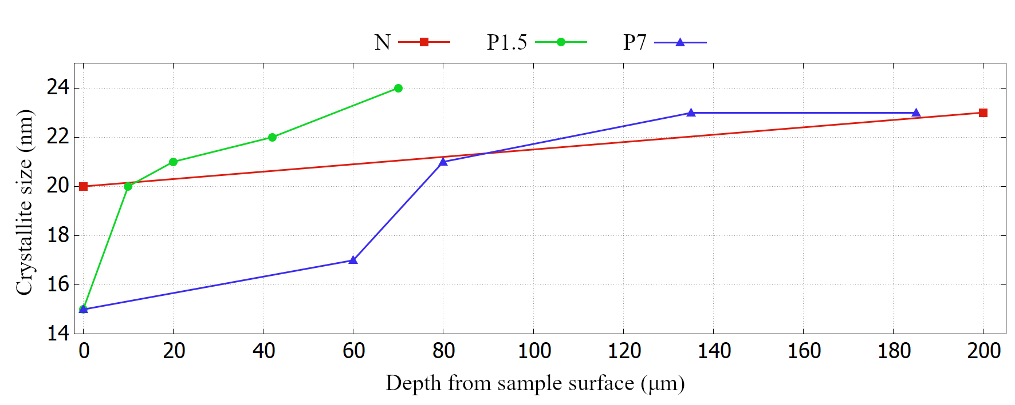
Figure 1. The depth distributions of the crystallite size analysed by using {220} diffraction line.

Results and discussion
The results of crystallite size analysis are shown in Fig. 1. For sample N, only the values from surface and first measured depth are shown. The size of crystallites at the surface was 20 nm and at the first measured depth 23 nm. With increasing depth, the values fluctuated around 24 nm. The difference between two first values are caused by grinding and rolling, which influences near-surface layer more than regions deeper in the material.

After SP, the crystallites were reduced in their size. Its value was 15 nm at the surface, for both peened samples. With increasing distance from the sample surface, the crystallite size changed to values comparable to those for sample N. As can be seen, SP with higher intensity caused size reduction extending to deeper regions. For sample P1.5, crystallites were as big as those for sample N already from a depth of 10 μm. In deeper regions they were even bigger, which is caused by heterogenous microstructure of all samples before SP. For sample P7 the affected zone reaches up to 80 μm from sample surface.
Residual stresses in RD are shown in Fig. 2. The low tensile residual stresses were on the surface of sample N and could be neglected within the measurement error. As expected, SP led to an increase in compressive residual stresses (CRS) in near-surface regions. The largest values were directly at the surface, namely around 560 MPa for sample P1.5. As the depth increased, the values gradually decreased. At 40 μm from sample surface they transformed into tensile stresses with negligible values within the measurement error as in the case of sample N. Compared to P1.5, sample P7 had lower CRS at the surface with value around 400 MPa. However, at greater depths the residual stresses were more affected. The CRS reached their maximum values of about 700 MPa at a 60 μm depth. At the deepest measured region, the residual stresses decreased as for sample P1.5. More intense SP caused higher values of CRS deeper in the sample. On the other hand, the sample surface was more affected by SP with lower intensity. The reason is that the blasted balls did not have sufficient intensity to affect deeper areas of the material, but at the same time were capable of significantly deforming the surface and thus causing large residual stresses.
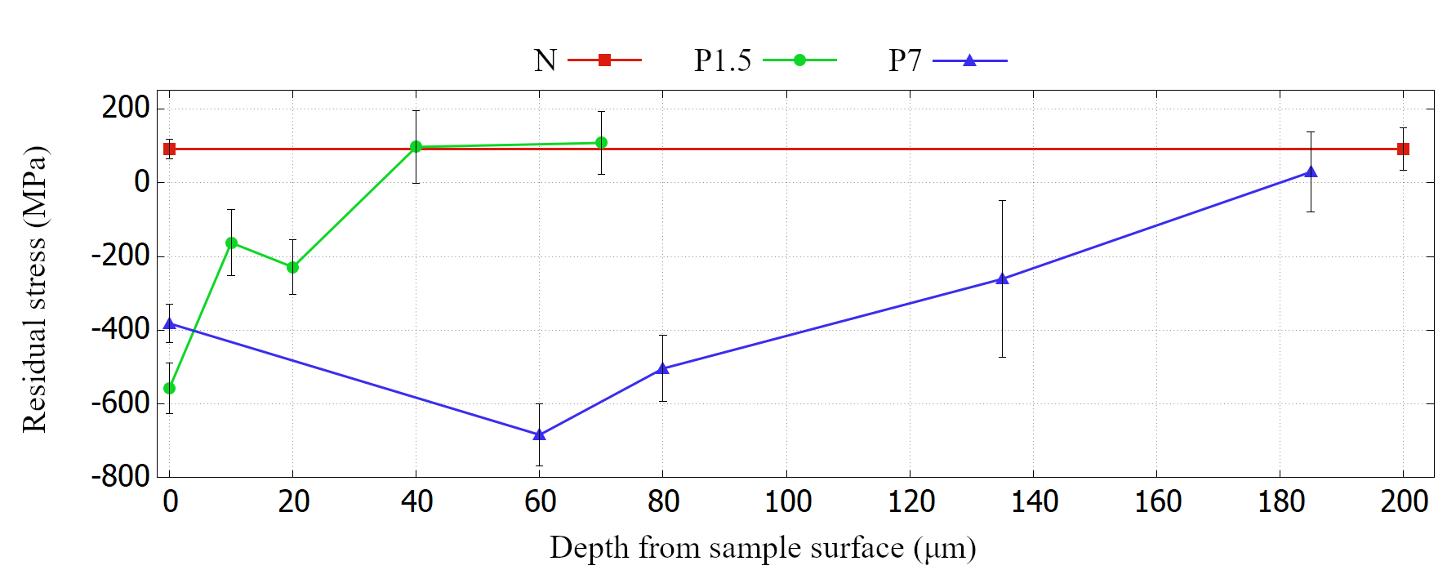
Figure 2. The depth distributions of the residual stresses of γ-Fe in RD.

Fig. 3 shows ODF in ${\text{φ}}_{\text{2}}$= 45° sections for each sample at selected depths. For N sample, the typical rolling texture of face-centred cubic materials was found. Crystallites were oriented along the α-fibre with a dominant Goss ({011}<100>) and Brass ({011}<211>) texture components. The Cu ({211}<111>) texture component was also present with lower intensity. At greater depths, the Brass and Goss components ceased to be resolved and the crystallites were oriented at lower intensities at positions between them. The intensity then increased with increasing depth. For sample P1.5, most of the crystallites had an orientation between Goss and Brass components, which becomes more isolated and intense with increasing depth. In Fig. 3 ODF for sample P1.5 in deeper regions had to be rescaled. The intensities were divided by 10 in order to match the used colour range. The ODF intensity is much higher compared to sample P7. Same as in case of residual stresses, the less intense SP caused greater change in near-surface regions and oriented most of the crystallites to same direction. The surface of sample P7 can be described by the texture along the α-fibre. As with sample N, the predominant crystal orientation was between the Brass and Goss components. With increasing depth, these texture components begun to isolate. For all samples, crystallites were mostly oriented along the incomplete α-fibre. SP caused only a small change in their preferred orientation. That may be explained by the deformation hardening of γ-Fe after rolling, which will thus better resist further deformation caused by SP.
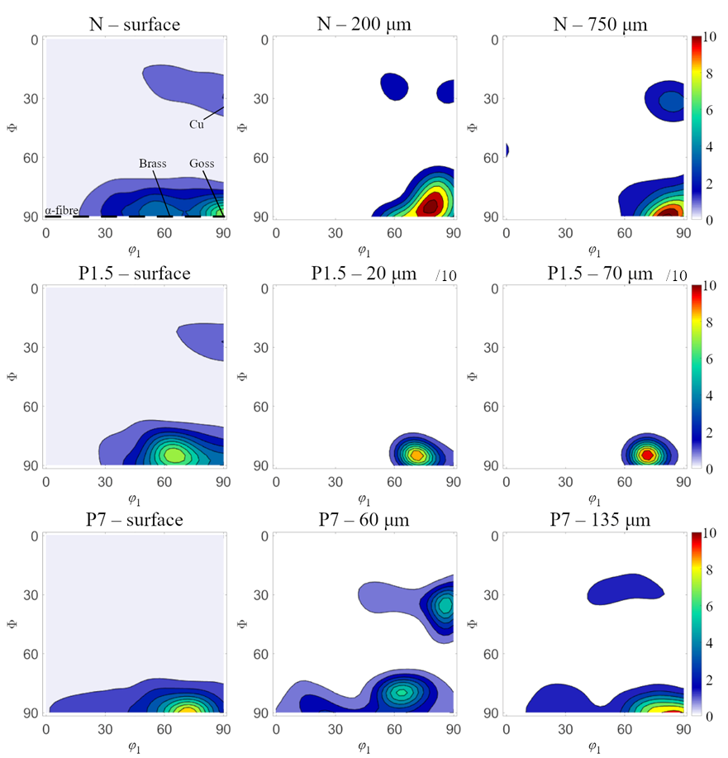
Figure 3. The ODF in ${\text{φ}}_{2}$= 45°. For sample N, α-fibre represented by dashed line and Goss, Brass, and Cu texture components are shown.

Conclusions
Shot peening alters the real structure parameters of materials which results in a change of their final properties. The effect of shot peening on γ-Fe phase of rolled duplex steel 1.4470 was studied. The main goal was to evaluate the depth distribution of crystallite size, residual stresses, and texture after shot peening with different intensity. Shot peening caused a reduction in crystallite size mostly in near-surface region. With higher intensity, the affected zone increased. Similar effect had shot peening on compressive residual stresses. With higher intensity, the larger stresses deeper in the sample were found. Shot peening with lower intensity caused the biggest change right at the surface of the sample, where compressive residual stresses exceeded values measured for sample P7. Less affected by shot peening was the texture of the samples. Most crystallites only slightly changed their orientation, while remaining in an incomplete α-fibre.

References
- TMR Stainless. Practical Guidelines for the Fabrication of Duplex Stainless Steel. IMOA, London, 2014.
- J. Champaine. Shot Peening Overview. The Shot Peener, 2001.
- F. Bachman, R. Hielscher, H. Schaeben. Texture Analysis with MTEX – Free and Open Source Software Toolbox. Solid State Phenomena 160: 63-68, 2010
This work was supported by the Grant Agency of the Czech Technical University in Prague, grant No. SGS22/183/OHK4/3T/14.

